**Using This Program**

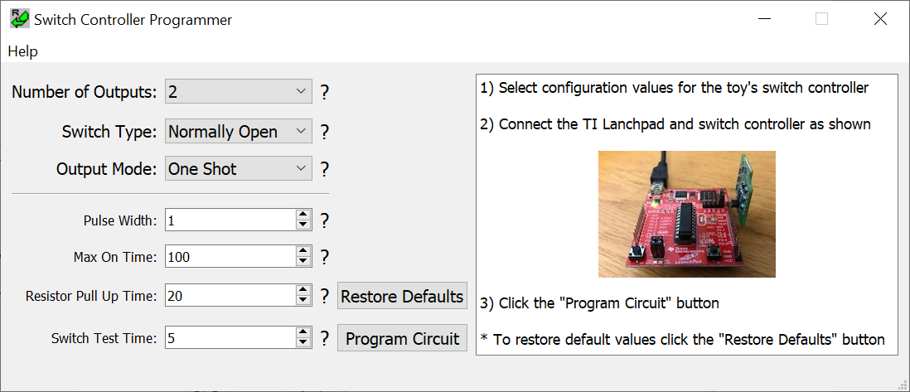

Uploading Firmware:

* Select the configuration values for your toy using the options on the left. Options below the dividing line are advanced, and will probably not need to be modified
* Click “Program Circuit” to upload your configuration to the switch controller. A window will open showing the progress of this process.
  + If uploading is successful, a small green light on the switch controller will flash briefly and the window should say “Success”. If it does not say success it will display an error message you can use to fix the problem

Other:

* Click “Restore Defaults” to reset all configuration values to their defaults
* Click “Help” to open various help manuals.